- Put TWO of the following arguments into standard form (numbering the premises and conclusion), eliminating unnecessary words.
  - Owing to the fact that the water is 75 degrees, you need not bring a wetsuit.
  - ~(p v q) is truth-functionally equivalent to ~p & ~q because they are always true together or false together, no matter what the truth values of p and q are.
  - “Whom best I love I cross; to make my gift, The more delay'd, delighted. Be content;”
  - “For nothing worthy proving can be proven, Nor yet disproven: wherefore thou be wise, Cleave ever to the sunnier side of doubt”

Ans:
- Premise : Water is 75 degrees.
Conclusion: You do not to bring a wetsuit
- Premise: ~(p v q) and ~p & ~q are true together or false together no matter
Conclusion: ~(p v q) is functionally equivalent to ~ p & ~q

- List three reason (premise) markers and three conclusion markers.
Reason markers– Since, Because, For.
Conclusion markers – Therefore, Hence, Thus.

- Define validity
Ans: validity refers to the feature of an argument consisting in the fact that the truth of the premises logically guarantees the truth of the conclusion. Whenever the premises are true, the conclusion must be true, because of the form of the argument.
- Define soundness
Ans: Soundness implies that argument is valid and that all of its premises are true.
- Define suppressed premise:
Ans: Refers to a statement whose part of the part of an argument that is missing

Truth conditions for “p ⊃ q”

p | Q | p ⊃ q
T | T | T
T | F | F
F | T | T
F | F | T

For problems 6-9, assume that A, B, and C are true and that X, Y, and Z are false. Determine whether the following compound propositions are true or false. Show your work.

- A & [(~B & ~C) & (~X v ~Y)]

B is true then ~B is false
C is true then ~C is false
X is false then ~X is true
Y is false then ~Y is true

& for “and” , V for “as”
~B & ~ C is false (as ~B and ~C are false)
~X v ~Y is true (Because bot ~X and ~Y are true)
~B & ~C) & (~X v ~Y) is false (Because ~B & ~C is false, ~ ~X v ~Y is true, they are joined with & so its value is false.
A & [(~B & ~C) & (~X v ~Y)] is false (because of the above reason for any A, B, “A & B” it is true only A is true and B is also true)

- (X ⊃ ~A) & (~~Y v ~Z)

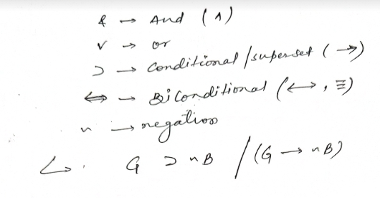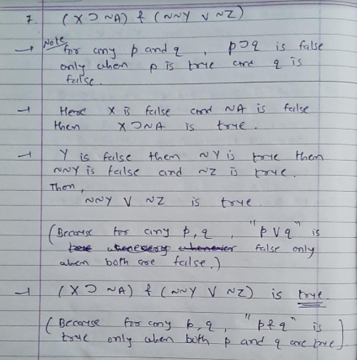
- (~B v C) v (X ⊃ B)
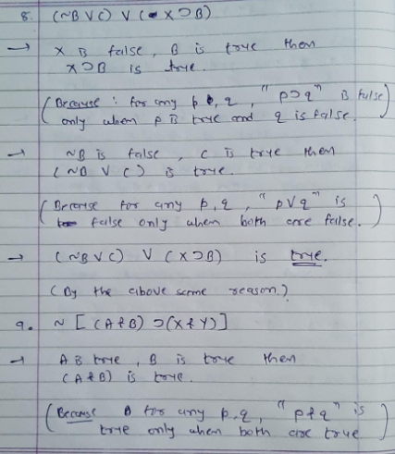

- ~ [(A & B) ⊃ (X & Y)]
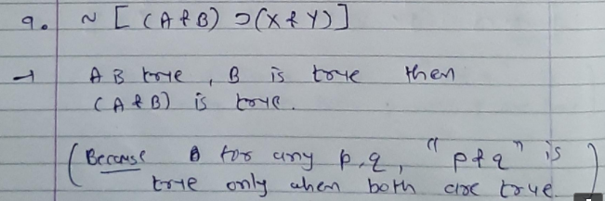
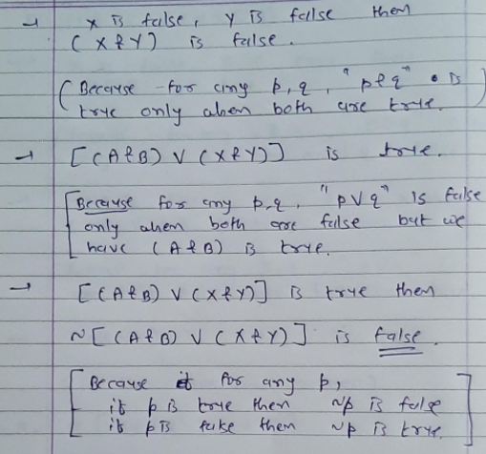
For problems 10-12, use truth tables to determine whether the expressions are truth- functionally equivalent or not. If equivalent, write “TFE.” If not equivalent, write “not TFE.”

- ~~p & ~~q and ~ (~p v ~q)

p q | (~~p and~~q)
F F | F
F T | F
T F | F
T T | T

~p | ~q | ~p v ~q | ~(~p v ~q
T | T | T | F
T | F | T | F
F | T | T | F
F | F | F | T

Conclusion: So they are equivalent (TFE)

- ~(p ⊃ q) and ~(~p v q)
~(p ⊃ q)
p q | (p ⊃ q) | ~(p ⊃ q)
F F | F | F
F T | F | F
T F | F | T
T T | T | F

And
~(~p v q)
~p | ~p v q | ~(~p v q)
T | T | F
T | T | F
F | F | T
F | T | F
So theyare equivalent ( TFE)

- ~(p & ~q) and ~p v q

~(p & ~q)
p q | ~(p & ~q)
F F | T
F T | T
T F | F
T F | T
And ~p v q

~p | ~p v q
T | T
T | T
F | F
F | T
So they are equivalent to (TFE)

For problems 13-17, use truth tables to determine whether the argument forms are valid or invalid.

- p ⊃ q
P | Q | & | p ⊃ q  T | p ⊃ & | q ⊃ &
T | T | T | T | T | T
T | T | F | T | F | F
T | F | T | F | T | T
T | F | F | F | F | T
F | T | T | T | T | T
F | T | F | T | T | F
F | F | T | T | T | T
F | F | F | T | T | T

the argument is valid because it has the equivalent

- p ⊃ r

:. q ⊃ r

P | q | & | P v r | p&q | q&p | (p ⊃ q) v (q ⊃ p
T | T | T | T | T | T | T
T | T | F | T | T | T | T
T | F | T | T | F | T | T
T | F | F | T | F | T | T
F | T | T | T | T | F | T
F | T | F | F | T | F | F
F | F | T | T | T | T | T
F | F | F | F | T | T | T
Valid arguement

- p v r

:. (p ⊃ q) v (q ⊃ p)

P | Q | r | p⊃(q v r) | p ⊃ q
T | T | T | T | T
T | T | F | T | T
T | F | T | T | F
T | F | F | F | F
F | T | T | T | T
F | T | F | T | T
F | F | T | T | T
F | F | F | T | T
Valid argument

- p ⊃ (q v r)
p ⊃ q

:. r
- p ⊃ q
~p v q

:. ~(p & ~q)

- p
q v (p v r)

:. q v r

For problems 18-21, use symbols (&, v, ⊃, ~) and letters provide to translate the following sentences into logical form. (For example, “I love puppies (P) but not kittens (K)” translates into “P & ~K”.)
- I’ll go (G) only if you don’t wear that bowtie (B = You wear that bowtie).
- & = and
- v = or
- ⊃ = conditional / superset
- ⇌ = Biconditional
- n = Negation
~ G ⊃ nB/ (G nB)

Or
- Unless Jerry’s a liar (L), there’s a moose (M) on the loose!
(nL ⊃ µ)/(nL µ)
or
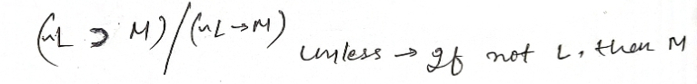
- John is a bachelor (B) if and only if he is a man (M) and is unmarried (U).
< B (M & U)

Or
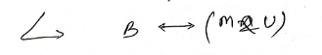
- Chuck is going to cry (C) whether or not the Chargers win (W). But if Chuck is going to cry and we’re out of tissues (T), then we’ll need to go to the store (S) to stock up.
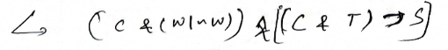

Extra Credit
Use a truth table to determine whether the following argument form is valid or invalid. For full credit, you must accurately fill in the entire table. (5 points possible)
(p ⊻ q) ⊃ (~p & r) q ⊻ r

:. ~(p ⊻ q)

